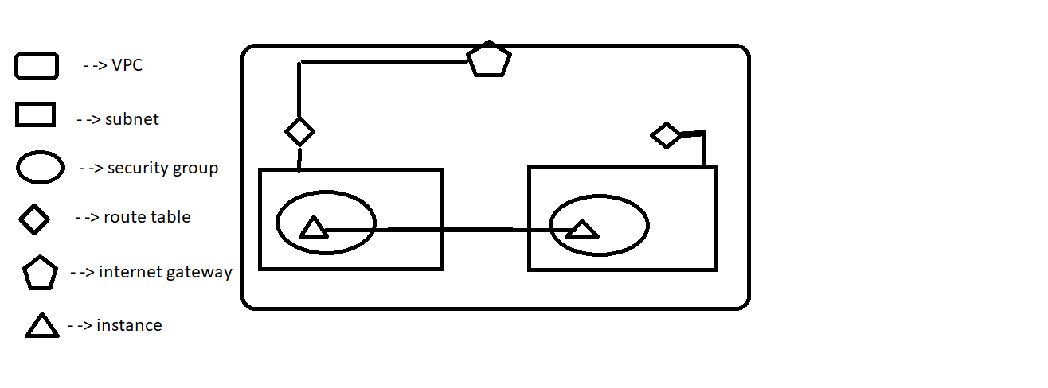

Internet gateway → Helps to provide internet to vpc

Route table → connect internet gateway with subnet

Security group → helps to set a permission who can access instances

Subnet → split the instances as a groups based on requirements

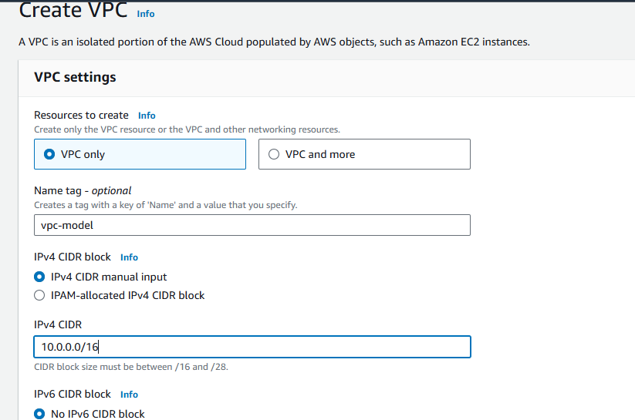

Create an new vpc at cidr range 10.0.0.0/16

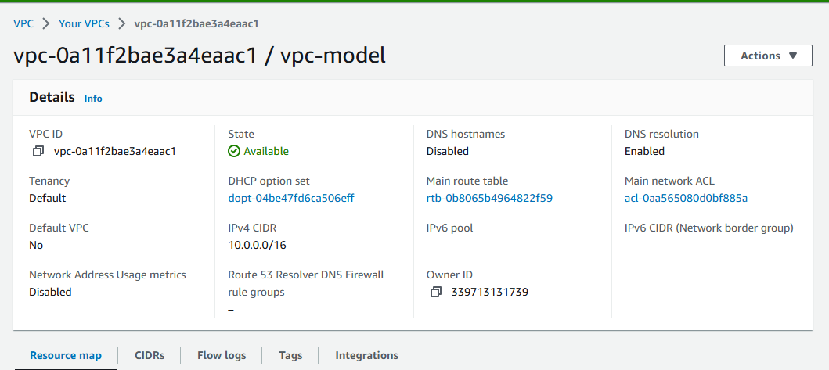

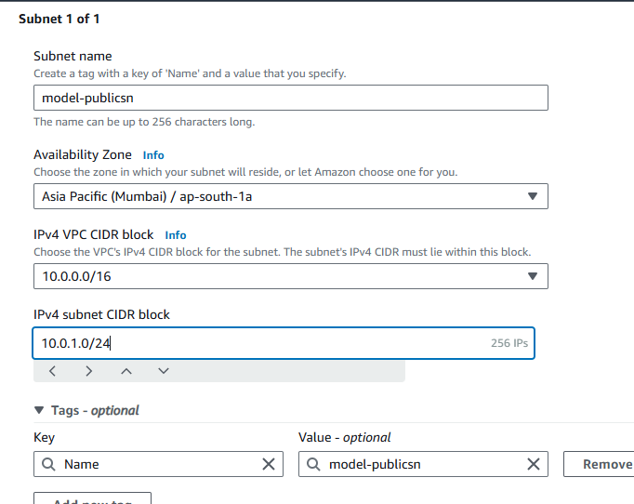

Create two subnet to store public instances and private instances

The subnet ip is ranged as 10.0.1.0/24 and second one is ranged as 10.0.2.0/24

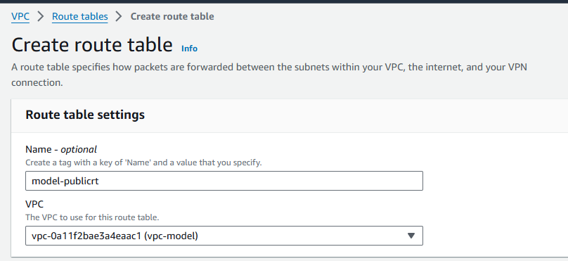

Create route table for both the subnets

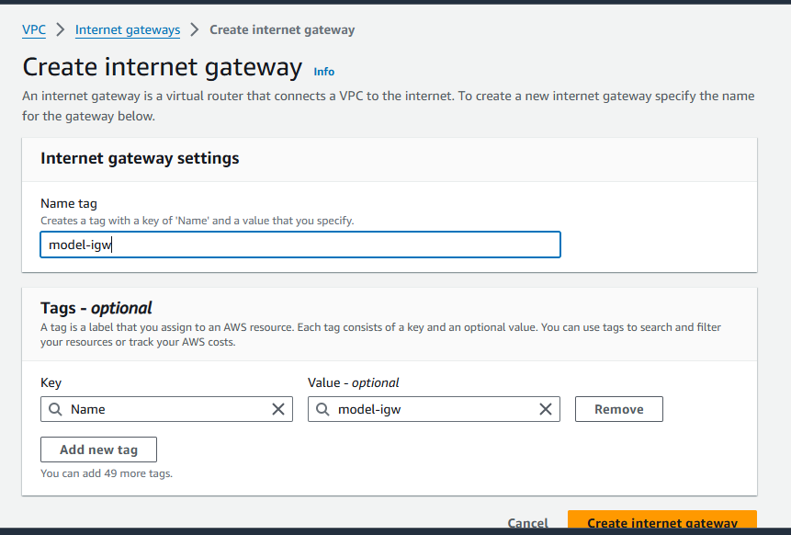

Create an internet gateway to configure with vpc

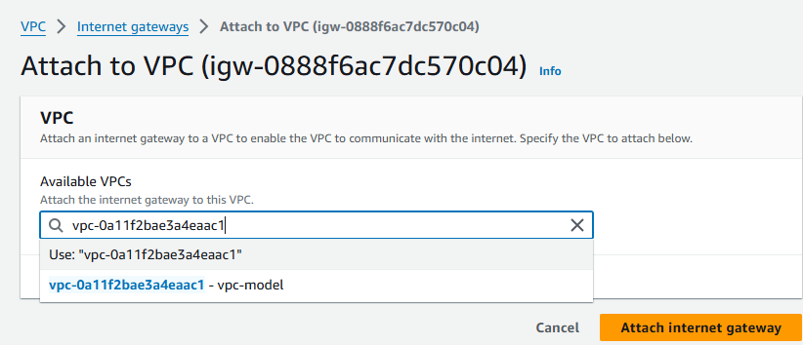

Attach internet gateway with vpc

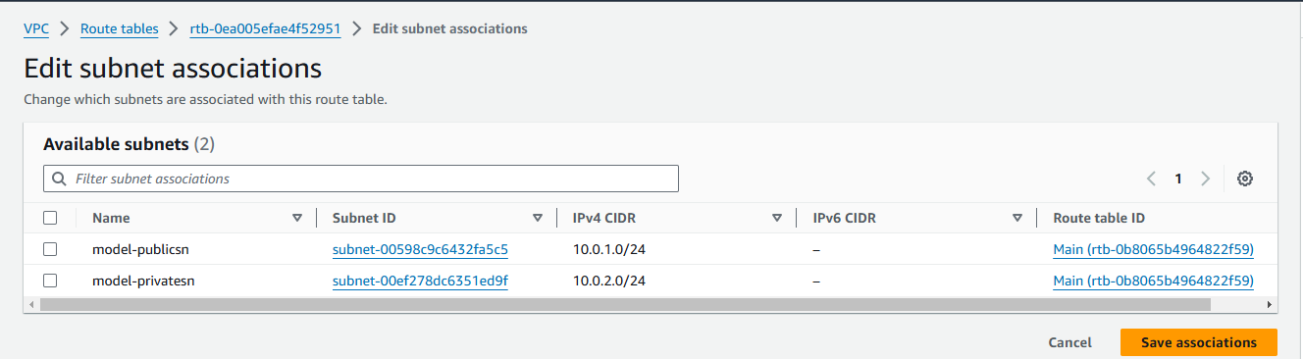

Associate route table with subnet